Subject Management Micro-service

Sep 20, 2021

Developer

**Harsh Mange**

Technologies **1**

Technologies **1**

External packages **1**

REST APIs **2**

Class Diagram **3**

Database Model Snapshot **4**

Staff 4

Subject 4

Output Snapshots **5**

## Languages

HTML

CSS

JavaScript

## Technologies

Node.Js

MongoDB

Express.Js

## External packages

‘Body-parser’, ‘dateformat’

## REST APIs

* Create Staff Member: POST /api/staffmembers (Parse info using body-parser)
* Create Subject: POST /api/staffmembers/:username/subjects (Parse info using body-parser)
* Get Subject with queries: GET /api/staffmembers/:_id?[sub_name][&sub_code][&prof_name]

**[ ]** = optional & **sub_name** = subject name **sub_code** = subject code **prof_name** = professor name

I.e./api/staffmembers/harshmange?prof_name=ABCD&sub_code=MAT100

## Class Diagram

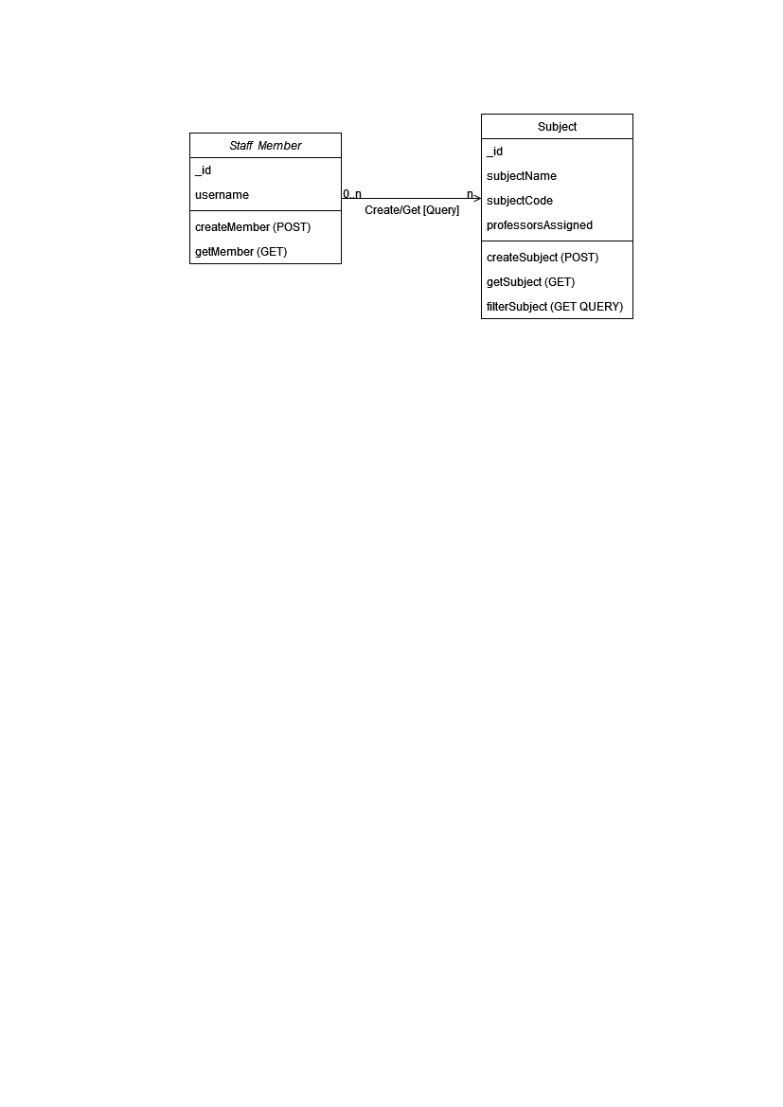

## Database Model Snapshot

### Staff

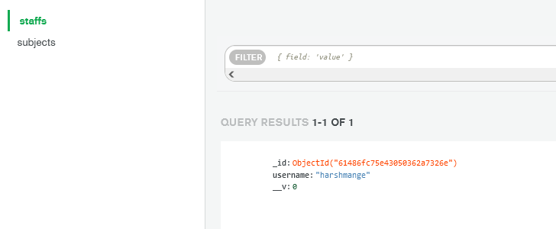

### 

### Subject

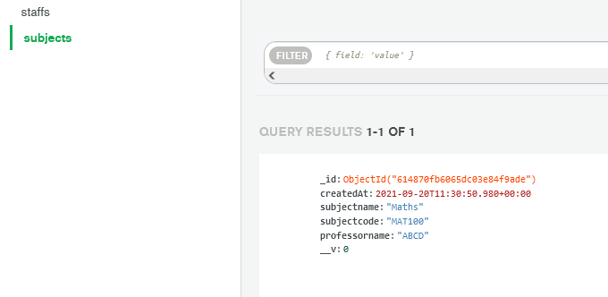

## Output Snapshots

1. **Homepage**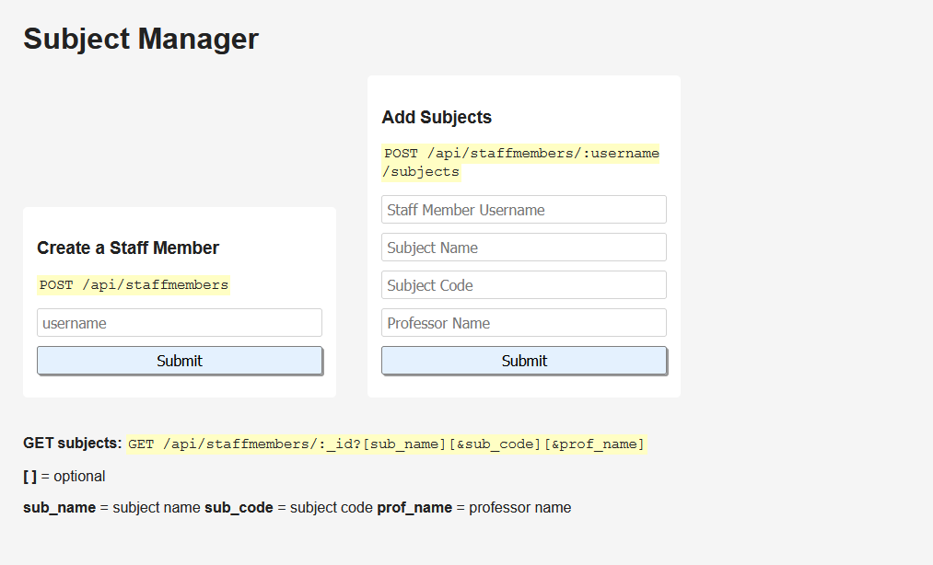
2. **Staff auth not found**

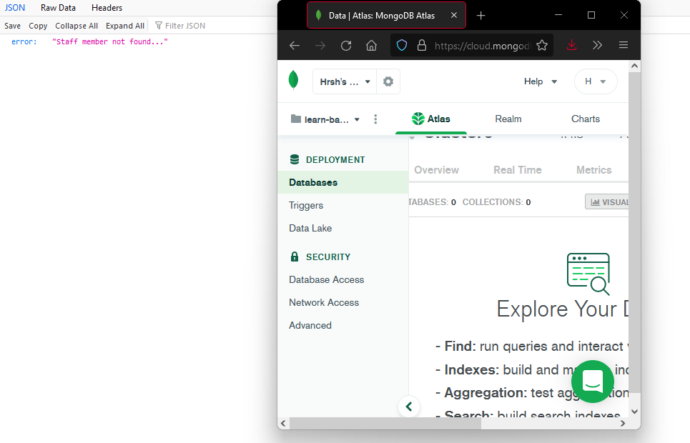

1. **Staff member created**

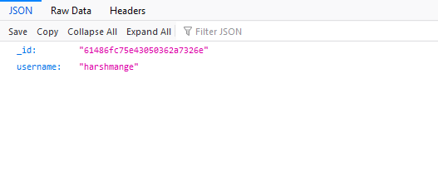

1. **Staff auth found subject created**

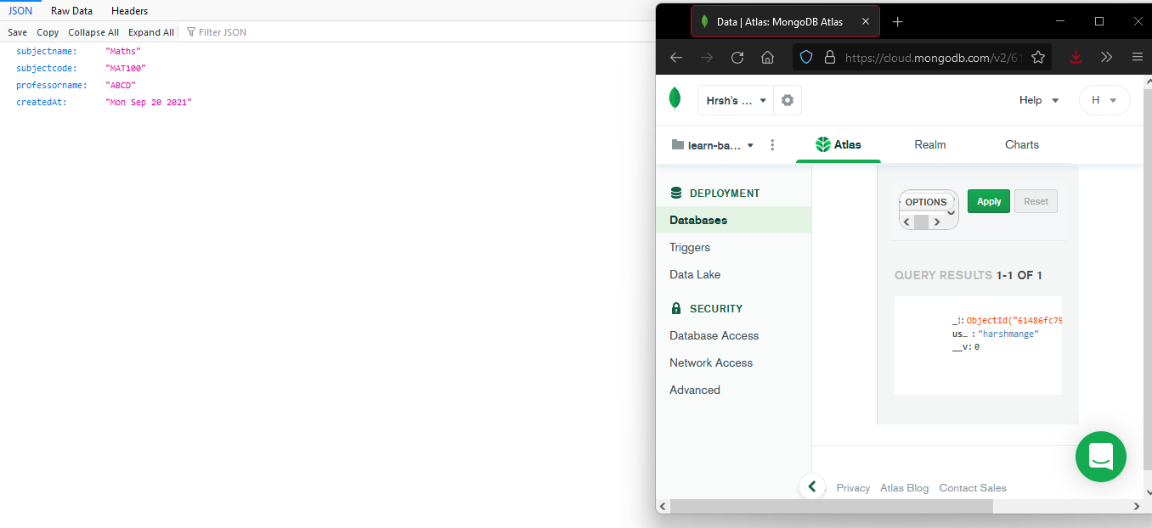

1. **Get subject by sub name & prof name**

